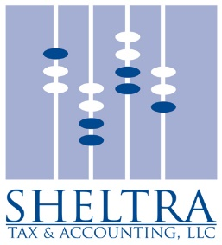

I hope that you and your family are healthy and ready for a post-pandemic world.

I will be uploading tax organizers and worksheets for you on my website (www.sheltratax.com – Client Documents) to download and fill out to assist in preparation of your tax return.

Please sign this engagement letter if you will be working with me for your 2021 tax preparation. Your signed letter assists me in determining how many clients I can take on this tax season.

This letter is to confirm our understanding of the terms of our agreement and outline the nature and extent of services we will provide. Based upon the information you furnish to us; we will prepare your Federal and applicable state income tax returns for 2021.

I will not audit or verify the data you submit to us, although we may ask you for clarification when necessary. All the information you submit to me will, to the best of your knowledge, be correct and complete and include all other information necessary for the completion of your tax return.

I will also prepare 2022 estimated tax vouchers if required, based on your income and withholding taxes for 2021. If you anticipate a substantial change in income or withholding taxes for 2022, please advise me as soon as possible. I will then determine whether an adjustment should be made to your tax estimates.

Your returns are subject to review by the taxing authorities. Any items that may be resolved against you by the examining agent are subject to certain rights of appeal. In the event of an examination, I will be available upon request to represent you, or to review the results of any examination. Fees will depend upon the scope of the engagement. My fee does include basic tax letters you may receive during the year. The charges for my services are based upon my fee schedule and the complexity of the returns.

You have the final responsibility for your income tax returns. Please review them carefully before you sign and mail them.

The privacy client information has always been important to me, and I have always been bound by professional standards of confidentiality. However, I am required by law to formally inform you of my privacy policy.

I collect nonpublic personal information about you that is provided by you or obtained by me with your authorization. This information may come from various sources, including information I receive from personal interviews, tax organizers, worksheets and other documents necessary to provide professional services to you.

I do not disclose any nonpublic personal information about clients or former clients to anyone, except as permitted or required by law.

I look forward to hearing from you soon. As always, contact me if you have any questions.

Sincerely,
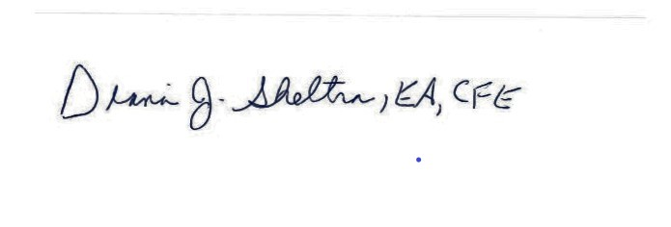
Diana J. Sheltra, EA, CFE
Enrolled Agent
Certified Fraud Examiner

________________________________ _____________________
Client Signature Date

_________________________________ ______________________
Client Signature Date

